KV Models

NYS&W RS1 Exhaust Stack Guide Sheet

Part Identification

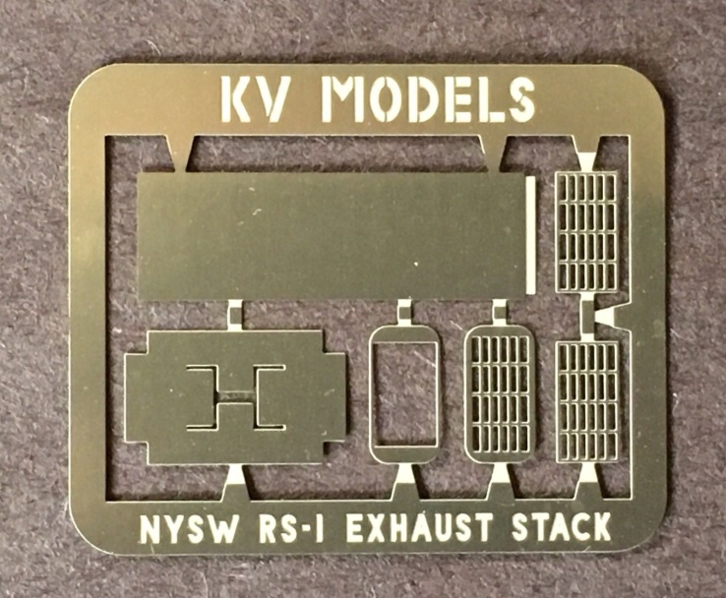

Upper Left – Exhaust Stack Body

Upper Right – Exhaust Stack Grille (top)

Lower Right – Exhaust Stack Grille (middle)

Lower Right Center – Exhaust Stack Grille Top Plate

Lower Left Center – Exhaust Stack Base Mounting Flange

Lower Left – Exhaust Stack Base

Step 1

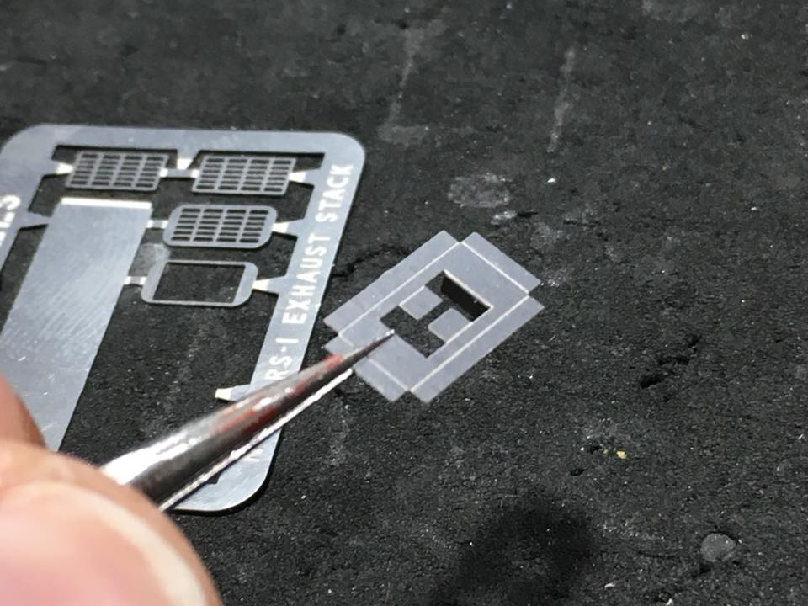

Remove Exhaust Stack Base from fret. Bend inner exhaust stack guides downward. Note that the base is actually upside down. The fold lines should be facing inside the assembled stack base, not the outside.

Step 2

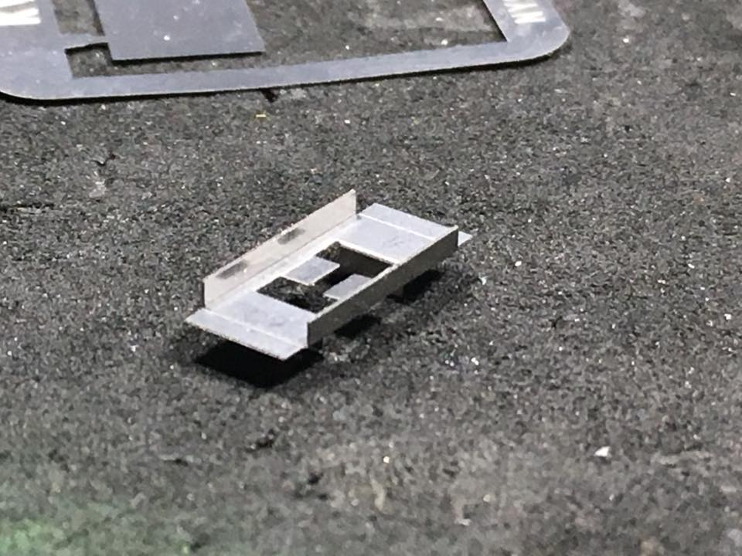

Fold the Exhaust Stack Base sides upward. The base is actually upside down in the photo.

Step 3

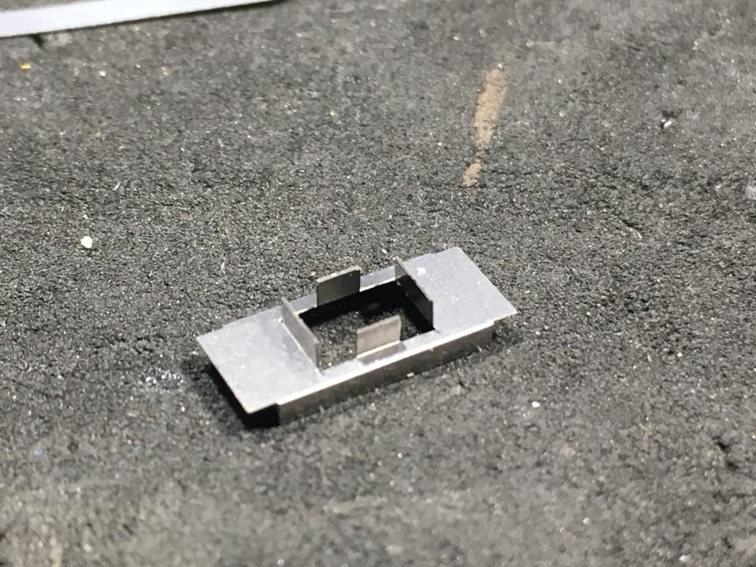

Fold the remaining inner exhaust stack guides upward. Note that the Exhaust Stack Base is now right side up.

Step 4

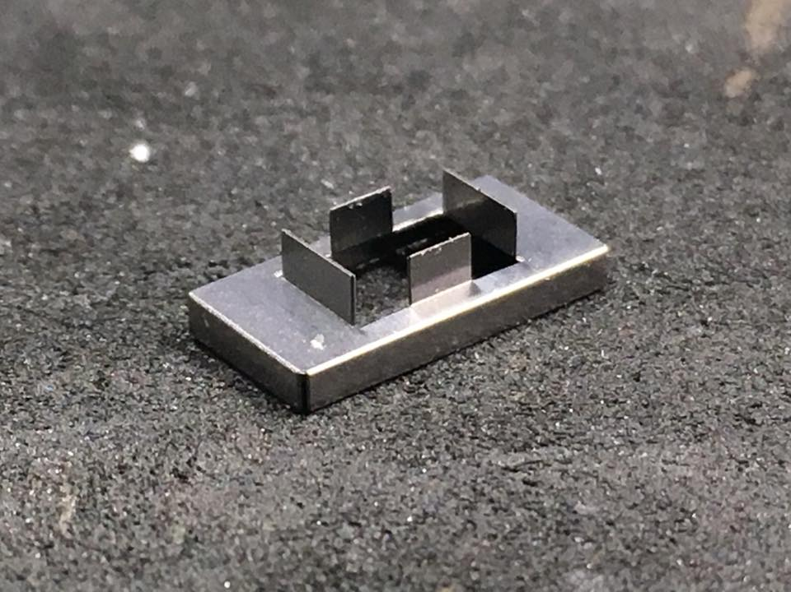

Bend the remaining Exhaust Stack Base sides downward.

Step 5

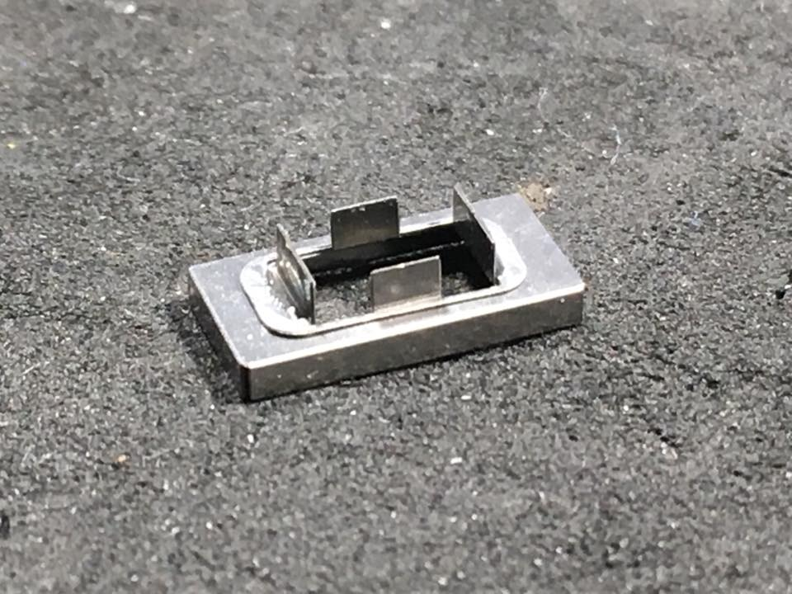

Attach the Exhaust Stack Base Mounting Flange to the Exhaust Stack Base. The flange slides over the inner exhaust stack guides. This flange will guide the Exhaust Stack to the proper location and give the stack something to be attached to! Use CA to attach the flange to the base. A drop on top of the flange, up against the inner exhaust guide will hold the flange in place.

Step 6

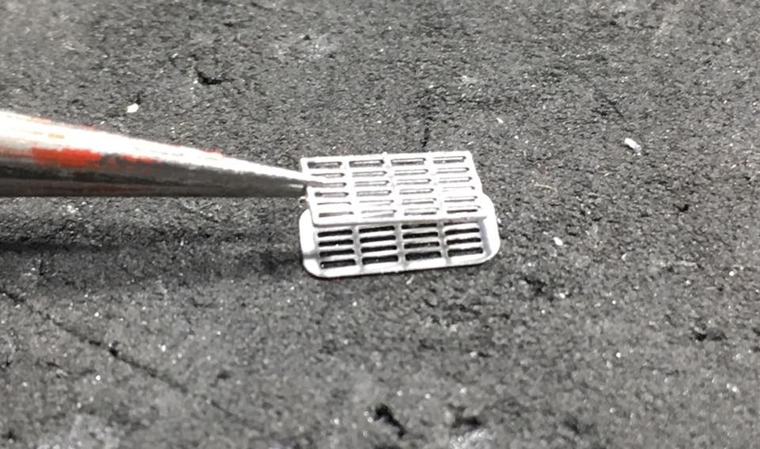 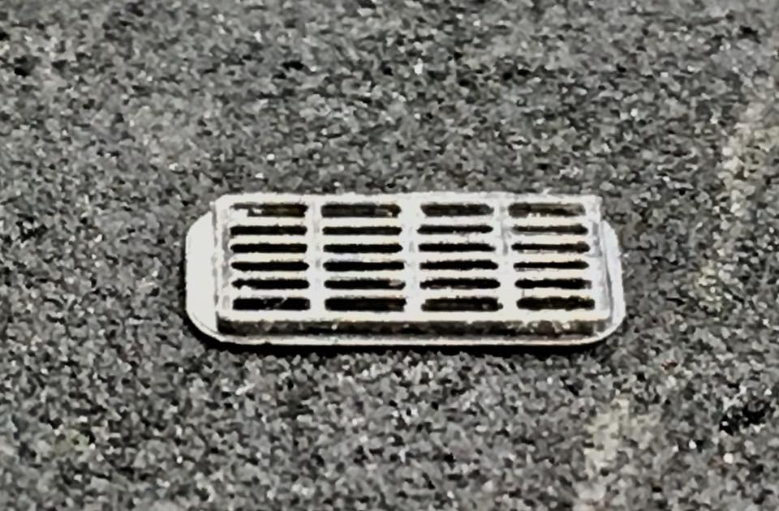

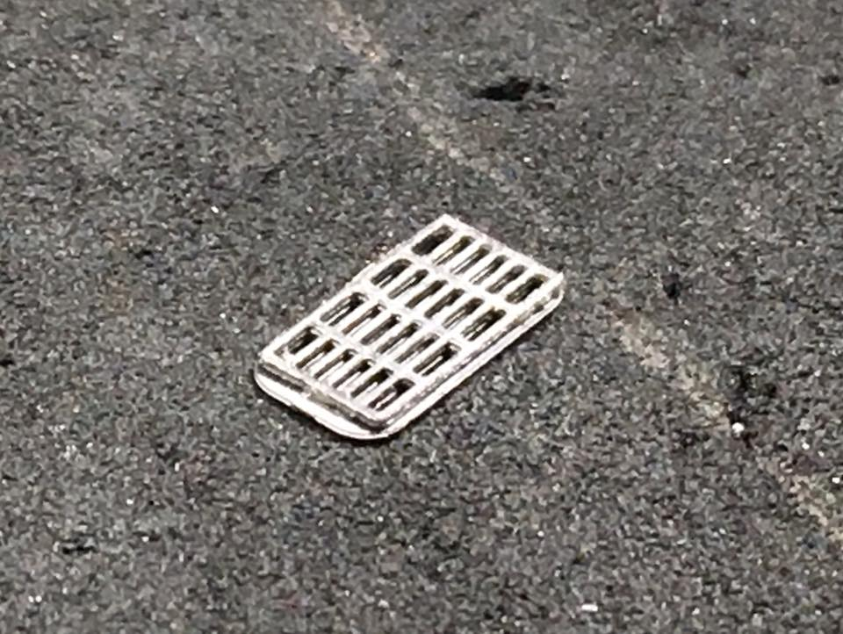

Add the two Exhaust Stack Grilles to the Exhaust Stack Top Plate. The two grilles are the same so order of application does not matter. I attach the two grilles together using a small dab of CA along the edges. Once that is a single unit, I attach that to the Exhaust Stack Top Plate with a little CA. If the CA leaks into the openings it is possible to remove it by wicking it out with a tissue or paper towel.

Step 7

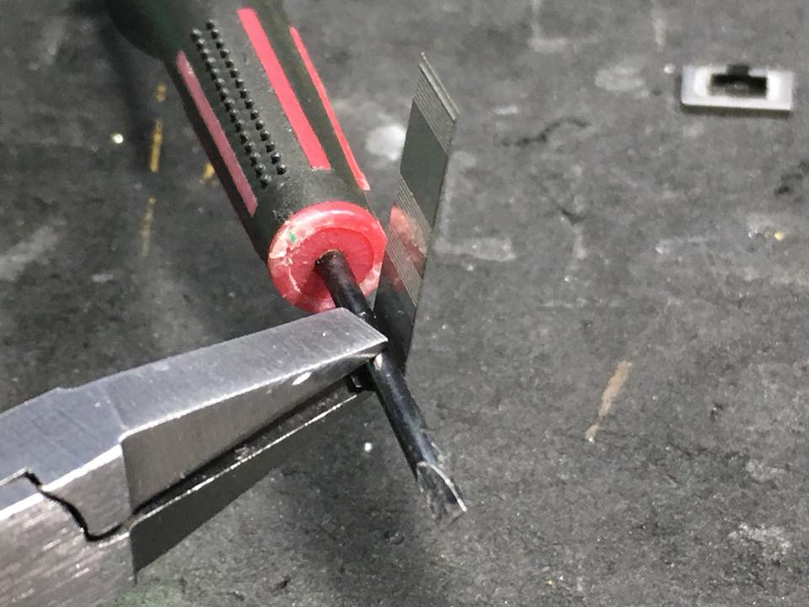

The Exhaust Stack requires the corners to be bent to the proper radius. This is difficult to get on the first try so I like to get a “ballpark” radius and then fine tune the radius once the 4 corners are bent and the stack is assembled. I use the shaft of a small screwdriver as a bending guide. The radius is roughly 1/16” diameter. I place the guide inside the stack (the inside is where the bending guide lines are) and use a pair of flat nose pliers to bend the exhaust stack around the guide.

Step 8

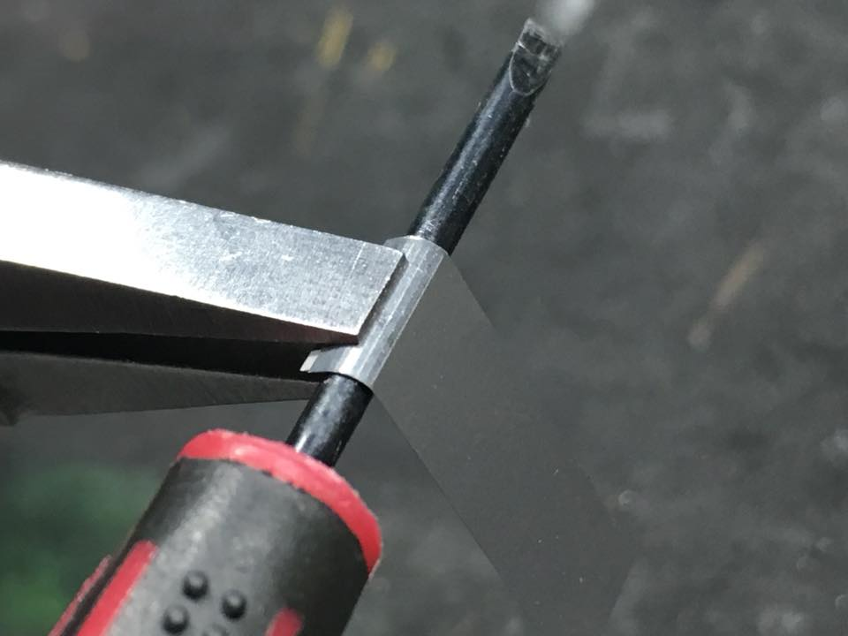

A small screwdriver is used as a bending guide for the rounded edges of the exhaust stack. Flat nosed pliers bend the metal around the guide.

Step 9

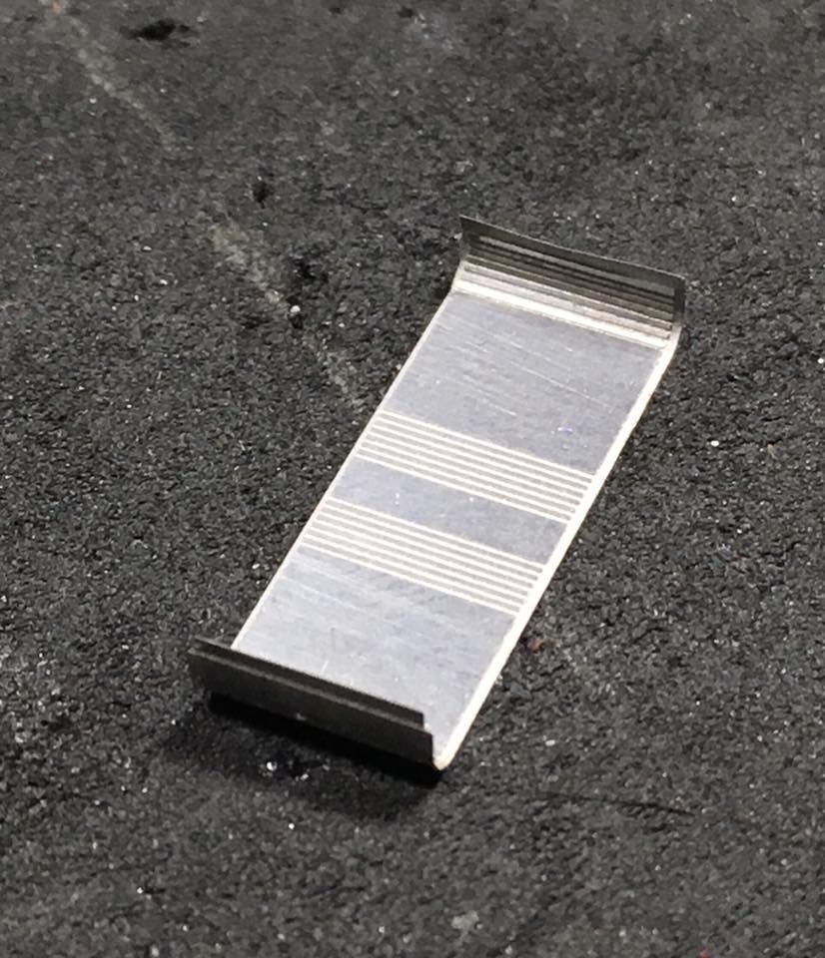

I bend the outer edges first.

Step 10

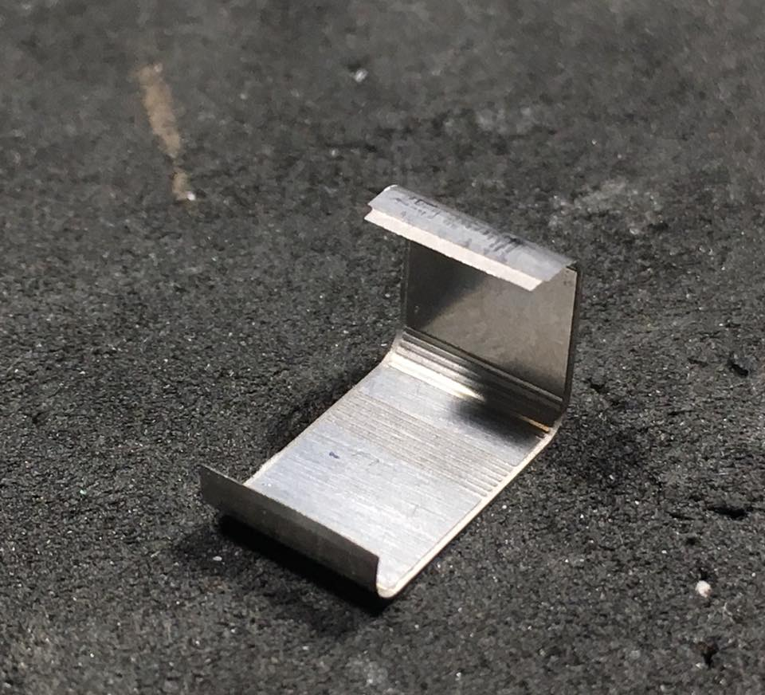

I have bent the outter corners first and then started bending the inner corners. The outer corners are next to the vertical seam on the stack. The last bend is tricky because it will be difficult to maneuver the pliers around the bent corners.

Step 11

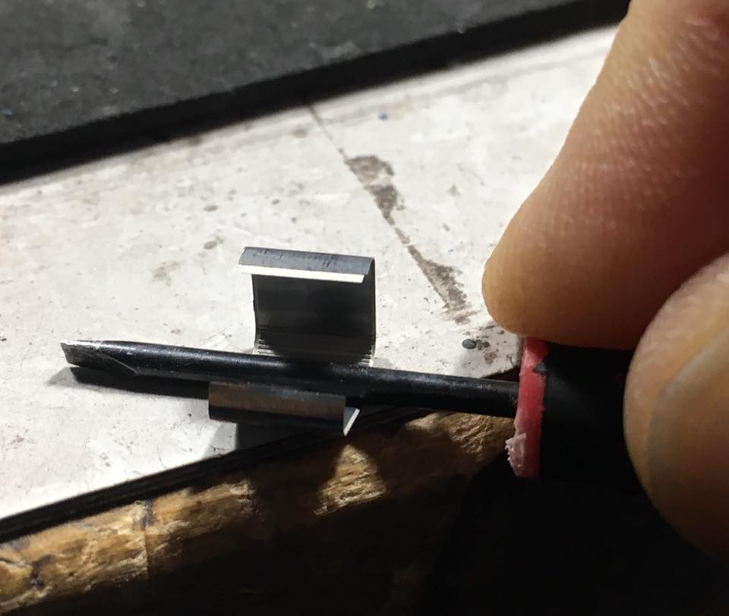

The method I have developed for achieving the final bend is to place the bending guide on the inside of the stack and press that firmly against the stack and a soft base such as the matt on my workspace. This will start a bend which can then be completed using fingers to massage the metal around the guide.

Step 12

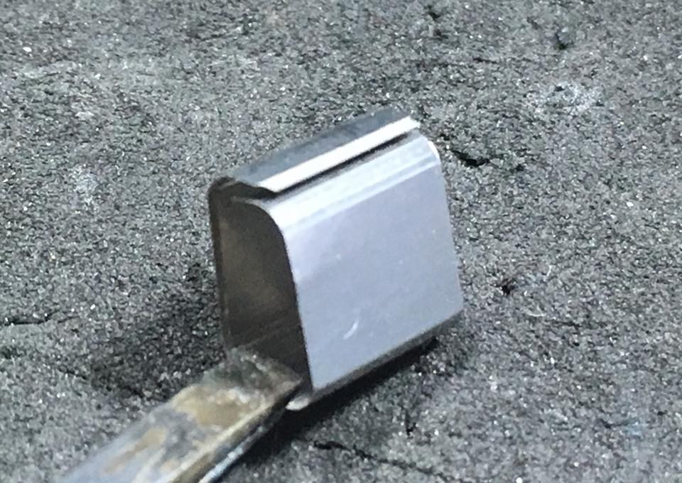

The 4 bends were pretty close to correct but not 100% which is normal. I will fine tune the bends when the stack is assembled. The seam consists of an inner flange and a recess. The edge with the recess slides over the edge with the flange. A bead of CA on the flange will hold the two edges together. Note that the edge with the flange is sitting slightly higher than the edge with the recess. That tension will hold the edges together as the CA dries.

Step 13

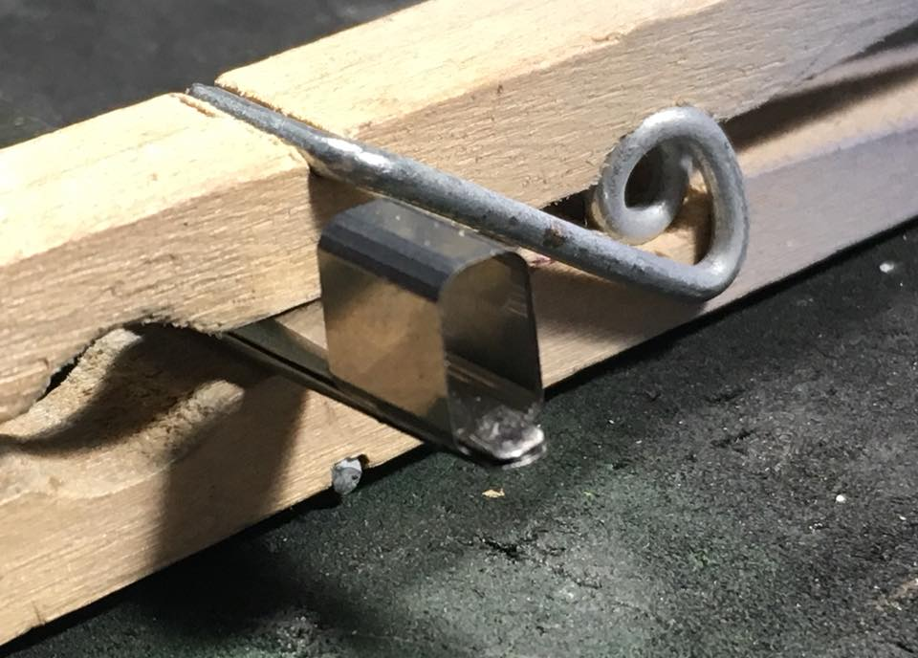

Once the seam is attached with CA, I use a pair of flat nosed tweezers clamped with a clothespin to keep the parts aligned while the CA dries. There will be some CA ooze on the exterior. That can be scraped off with an X-acto blade later on.

Step 14

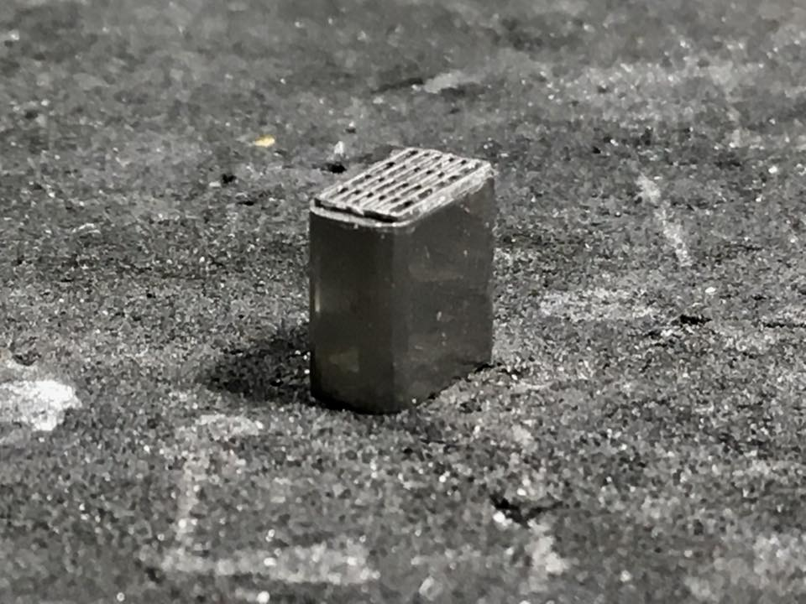

The Exhaust Stack Top Plate Assembly will be used to fine tune the radius of the corners. If the stack is too wide you can press the stack in the center to cause the ends to expand. Same process if the stack is too narrow. It is a good idea to reinforce the seam with some clamped tweezers to keep the seam from spreading. Once the stack matches the Top Plate you will notice that there is a small shelf for the plate to be mounted to inside the top of the stack. A small bead of CA will keep the two parts firmly attached.

Step 15

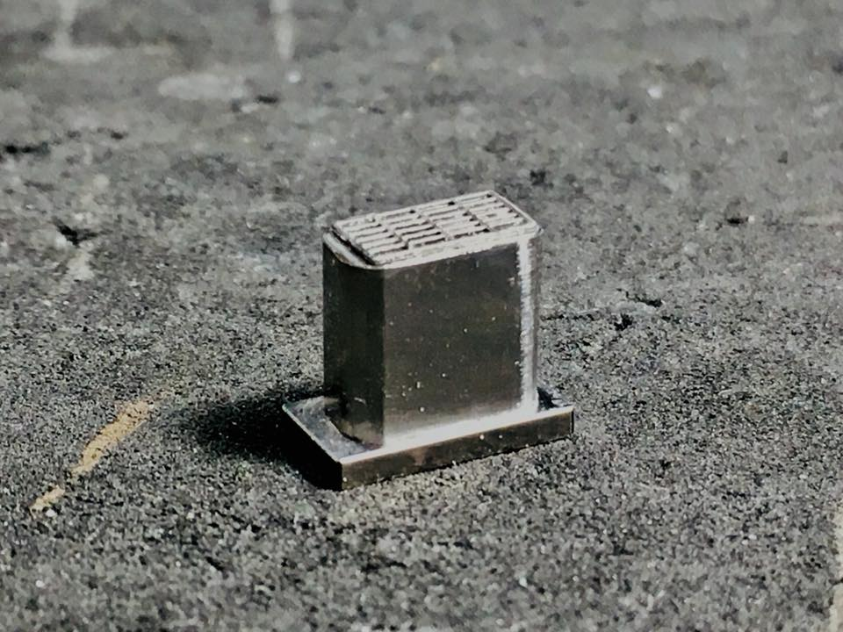

Once the top plate is successfully mounted, mount the assembly to the Exhaust Stack Base. Use the same method for attaching as the top plate. A small bead of CA round the inside of the stack will keep the stack and the base together.

Step 16

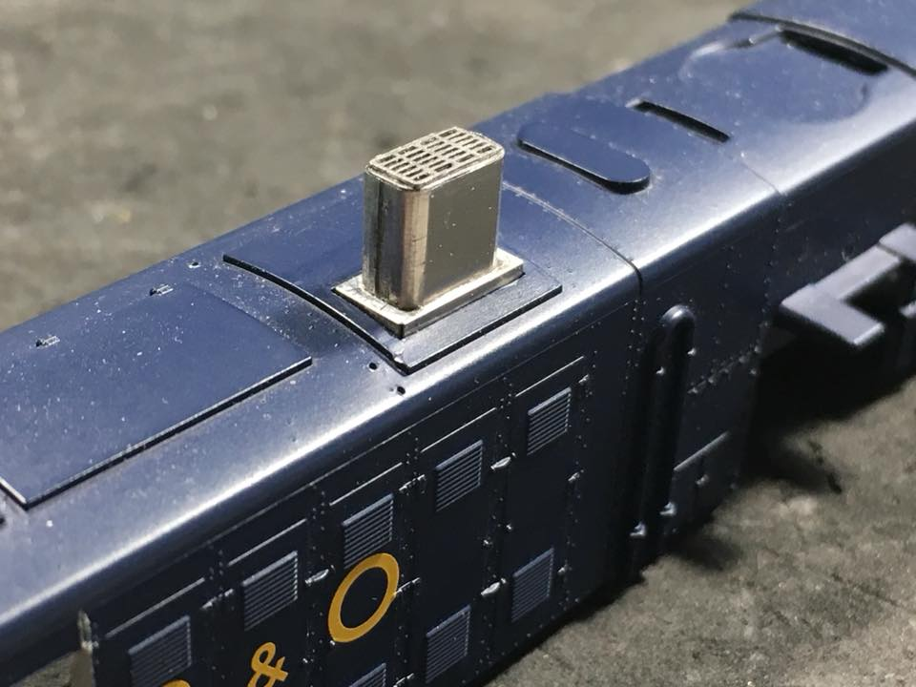

The final step is to attach the stack to the model. The base should fit in the rectangular opening on the model. A little CA will keep the stack in place.